Name____________________________Date____________Period__________ISN#
Free Trade
Warm Up
- Based on the graph what can you conclude about the impact of NAFTA?

Definitions
Tariffs | Free Trade Zones

Free Trade Goals:
- ___________________Trade (no tariffs)
- __________________economies of member countries
- Help member countries become more ________________ on the __________________________
- _____________________ (Free-Market Economy)
- ______________________ political ties and stability

Organization | NAFTA | DR-CAFTA | Mercosur
Date started
Goals
Countries involved
Impact
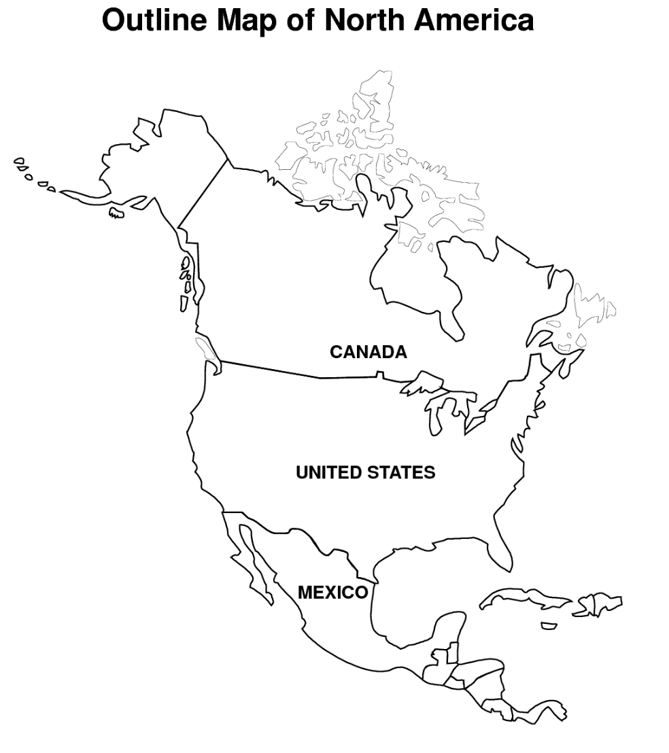

Key

Canada

United States

Mexico

Summarize the Article and write a response below using the following stem.
Although NAFTA was supposed to help create jobs it:

_____________________________________________________________________

_____________________________________________________________________

_____________________________________________________________________

_____________________________________________________________________

_____________________________________________________________________

_____________________________________________________________________

_____________________________________________________________________

_____________________________________________________________________

