Name____________________________________________________Date____________Period_______
Washington, D.C. America’s Forward Capital

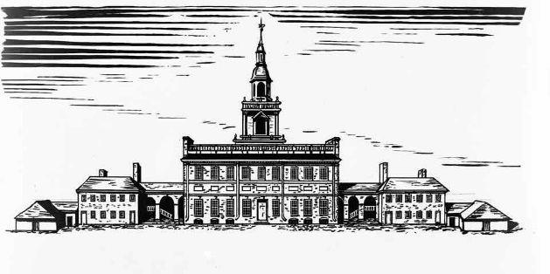
Directions: Read the article over Washington D.C. and apply what you know from the Forward Capital of Brasilia workbook activity by answering the questions throughout the reading. Highlight plus, or annotating, is worth 20 points.
The District of Columbia, known as D.C. or simply the District, serves as the seat of federal power in the United States. As it was established by the Residence Act of 1790, it is a forward capital city since this is not the original location of our nation’s capital city. Today DC is a diverse urban community of 700,000, surrounded by a much larger metropolitan area of close to 10 million people (including Maryland and Virginia suburbs).
1. How does Washington DC qualify as a Forward Capital, like that of Brasilia? (10 points)

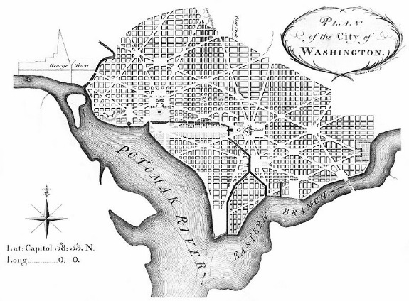
History- Before Congress established a permanent capital near Mount Vernon on George Washington’s plantation on the Potomac, New York City and Philadelphia had each been home to the capital of the young republic. Pierre L’Enfant, a French officer who served in the American Revolution and then remained in New York, designed a plan to move the capital city onto land ceded to the federal government from the nearby states of Maryland and Virginia. The site included the river port of Georgetown, which is now a very affluent neighborhood. Once President John Adams was elected, he moved the government to L’Enfant’s proposed location in 1800, partly in hopes of winning southern support (it didn’t work – Virginian Thomas Jefferson was elected later that year). John Adams was hoping to gain support by placing the capital between the Northern region and the Southern region of states. He hoped that by doing this, the country would be more united and no one section would have an advantage over the others. Adams also was thinking strategically. He wanted the capital to be an equal distance from all major borders to help prevent attacks and invasions or internal rebellions. Adams and many others decided to name the new capital city in George Washington’s honor. The letters DC stands for ‘District of Columbia” as it is an area that is not a state, but federal land and it honors Christopher Columbus.
2. What reasons were used to justify the moving of the Capital to its new location by John Adams and others? (10 points)

The image above is L’Enfant’s Plan for the “Federal City,” later named “Washington District of Columbia” or more modernly called Washington D.C. Adams had the White House, capital buildings, and various government buildings created along the Potomac River, right between Maryland and Virginia. Although this site was not the best land, as it was home to many swampy mosquito ridden areas, its general location and access to major water routes was very important to the growth of our new nation.
3. What key natural features were important in selecting the new location for the capital city? (10 points)

4. What type of region is Washington D.C.? Use your region notes if you don’t remember. (10 points)

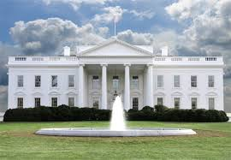
Today -Washington DC, although not in a central location to today’s standards, is a forward capital and has served as a well situated city. Some may ask why we haven’t moved the capital again, and the reason is at your fingertips… Literally. With today’s technological advancements, forward capitals are becoming less and less needed because friction of distance is being reduced with the ability to connect through technology. Washington DC has been moved multiple times in its history, but unless we see a major shift in political alignment (which is very unlikely) Washington DC will probably have the same location for many more years. Washington DC also now holds a sentimental place with most Americans, so moving it again is less and less likely.
5. If you were only considering geographic location, where would a better location for our nation’s capital be? Use an Atlas if needed. (10 points)

6. What are the main reasons as to why our Capital has not been moved to a more modern location? (10 points)

7. How are advancements in technology reducing friction of distance? Be specific. (10 points)

8. How does this article represent human geography? (5 points)

9. How does this article reflect Spatial Reorganization? (5 points)

