Name:_____________________________________________________Date:_______________Period:_____________
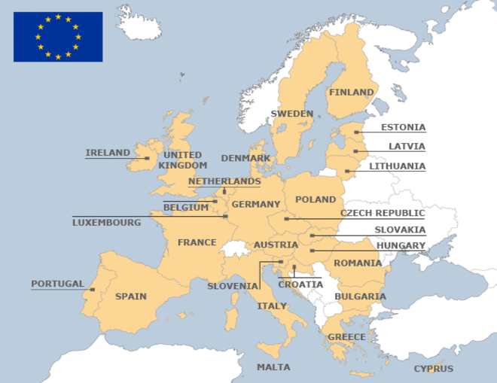
Directions: Highlighting Plus- You must highlight once a paragraph, and each time you highlight you must also write.

The European Union

How the European Union (EU) Works
1. The EU is a unique economic and political partnership between 28 European countries that together cover much of the continent. The five most influential countries, based on size and economic power are Germany, France, Italy, United Kingdom, and Poland.

Purpose and Plan of the EU
2. The EU was created in the aftermath of the Second World War to help repair the European continent as a whole due to mass devastation economically and politically. The plan was to foster economic cooperation; the idea that countries who trade with one another become economically linked and are less likely to have conflict.

3. The result was the European Economic Community (EEC), created in 1958. It initially increased economic cooperation between six countries: Belgium, Germany, France, Italy, Luxembourg and the Netherlands. What began as a purely economic union has evolved into an organization spanning many policy areas, from developmental aid, environmental concerns, and world health challenges. The EEC soon decided to change its name to the modern European Union.

4. The EU is based on the rule of law. All policies are founded on treaties that have been voluntarily and democratically agreed on by all member countries. These binding agreements set out the EU's goals in its many areas of activity.

Benefits of the European Union
5. The EU has delivered half a century of peace, stability and prosperity, while helping to raise living standards. One major way this has been achieved is through the use of the Euro. The Euro is the shared currency between 19 of the 28 member countries.

- Goods are moved freely between member nations without taxes
- People can move, cross, and work freely amongst member nations due to Open Borders
- Shared currency between member nations

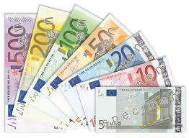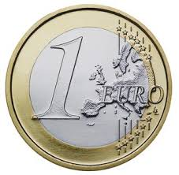
Human Rights and Equality
6. One of the EU’s main goals is to promote human rights, both internally, and around the world. Since the 2009 signing of the Treaty of Lisbon, the EU's Charter of Fundamental Rights brings all these rights and goals together in a single document. The EU's institutions are legally bound to uphold them, as are EU governments whenever they apply EU law. The EU’s main focus is:

1. Human dignity 2. Freedom 3. Democracy
4. Equality 5. The Rule of Law 6. Human Rights

Why Not All?
7. As the EU continues to grow and more countries join, the EU remains focused on making its governing institutions more democratic. However, there are many nations in Europe who feel that the EU is not a fair agency. For instance, Eastern European Countries who were originally linked to the Soviet Union are not allowed to join the EU unless they pay upfront fines and fees. Also, smaller countries refuse to join the EU because doing so would make their own governments invalid, as they would have to follow EU decisions, yet are not strong enough to make EU policy changes. Lastly, poorer nations are not allowed to join the EU because wealthy EU nations do not want cheap labor to flood their country since people can move and work freely, making prices and minimum wages go down.

Also, the United Kingdom in 2016 voted to leave the EU, an event known as Brexit (British exit), and is still in the process of negotiating the terms of their separation.

Lasting Effects
8. The European Union has developed into much more than an economic group, by becoming the influential political, economic, and human rights governing body that it is today. Led by its President, currently Jean-Claude Juncker, Europe is moving towards becoming a Supernation on a global scale. The EU is ready to take on worldwide issues as a continent, while protecting and advancing the ‘citizens of Europe’.

