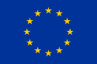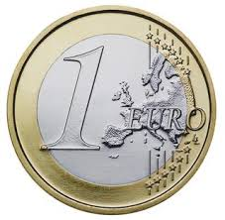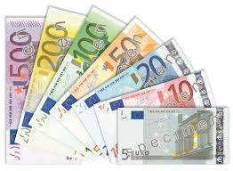

**7.** Why are not all European Countries part of the EU?

8. What’s term for UK’s separation from the EU?

**9.** Why are previous Soviet States forced to pay large fines before joining the EU?

(think Critically about past events).

**10.** What is a **SuperNation?**

**5.** Describe in Detail 3 Benefits of the EU:

1.

2.

3.

**2.** What was the European Union originally created to do?

**3.** What does it do today?

**1.** How many Member Nations are there? ______________________

List the 5 Major Member Nations:

1.

2.

3.

4.

5.

**6.** What are the Fundamental Rights of the EU?

**4.** What is the Rule of Law and how does the EU implement policy?