Name__________________________________________Date___________________Period__________ISN________
European Colonization of South America
Directions: Read the following information about European Colonization of South American then complete the mapping activity and the critical thinking questions that follow. Write in complete sentences and use the highlight plus method at least once every paragraph.
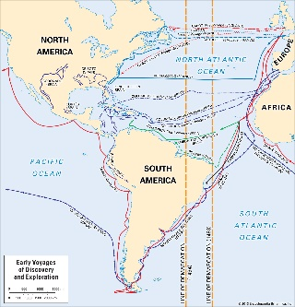
European nations during the period of the Renaissance- a movement of scientific exploration- began to explore outside of Europe in hopes of finding imperial wealth, gold and riches, and a way to spread their religion. All of these desires became a reality with the ‘discovery’ of the New World. Much like the colonization of history of North America, Latin America experienced a long history of territorial claims as well as European influences that would forever change the course of history.
During the 1400’s and 1500’s, Spain was one of the most powerful nations, led by King Ferdinand and Queen Isabella. This powerful monarch wanted to spread the reign of their crown, so they funded numerous explorations, like those of Columbus and later Magellan. Later, the Spanish Monarchy sent conquistadors like Hernan Cortez to lay claim to much of Latin America. Not only did Spain’s reach spread through the continent, their language, religion, and western culture reshaped Latin America. By the end of the 1600’s, Spain’s territory included modern day Mexico, Central America, Venezuela, Colombia, Ecuador, Peru, Chile, Argentina, Paraguay, and Uruguay. One the Spanish moved into these areas, local native groups either had to accept and assimilate or risk enslavement or death.
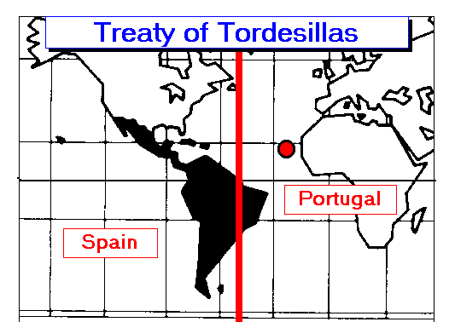
Spain was not the only European power to take notice of the rich land of the New World. At the same time, Portugal fell into conflict with Spain over territory control. To avoid fighting a war across the Atlantic, both countries agreed to divide South America, leaving modern day Brazil to the Portuguese. Not wanting to be left behind, France colonized French Guiana, while the Dutch controlled Suriname. The English, along with their North American territory, gained control of Guyana.
With the introduction of Europeans to these new territories, the New World began to change. Europeans introduced African slavery to the continent. Many Africans were forced into work throughout the region and today many places like Brazil, Venezuela, Guyana, Suriname and French Guiana have a high African ethnic presence. This unique culture has combined aspects from Africa, Native Peoples, and Europeans, and have been given the name mestizos.
Europeans also introduced religion into the areas, following the original goals of early Spanish explorers. Today, the majority of Latin America is Roman Catholic due to the early Spanish land claims. There are a few pockets where other Christian religions can be found, like in Guyana and Suriname. Also, deep within the Amazon Rainforest, indigenous religions are still dominate with native groups.
All in all, European colonization of Latin America forever changed the history of the region. As Europeans moved through Latin America they left behind a legacy that is still very apparent today. In the modern world, many Latin American nations have a weak governments and low economies due to the ever present territorial wars and eventual fights for independence that swept the continent once European powers moved out. Latin America, a richly diverse landscape, has been shaped by the convergence of people, goods, cultures, and languages for many centuries.
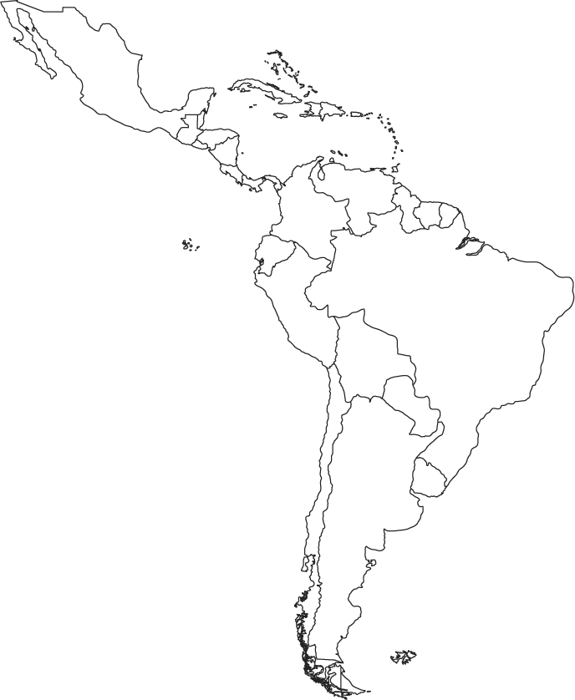
Mapping Directions- Use the reading to complete the map key and color the map accordingly to the key.
Spanish
English
Dutch
French
Portuguese
Indigenous
Christianity
Catholic
Mestizo

- Why, in paragraph 1, is the word discovery written in quotes?

- Based off the information in paragraph 2, what can you conclude to be true about Spain’s wealth and power in Europe in the 1500 and 1600’s?

- Why do you think Spain and Portugal would rather split South America than fight over it?

- Why were smaller empires, like that of the Dutch and France, so interested in South America?
- Why do people who call themselves mestizos have such a rich and diverse background?
- Explain why indigenous peoples of the Amazon never converted to Christianity.
- The last paragraph alludes to what major concept of exchange that changed the world?
- Looking at the map, what correlation can be made between colonization and language?
- How would Latin America be different today if the Spanish had found a passage to Asia and not colonized the ‘new world’?

- Which region of Latin America has the most diversity and why?

