Name_______________________________________________________Date__________Period___________
Europe Mapping Lab- Test Grade
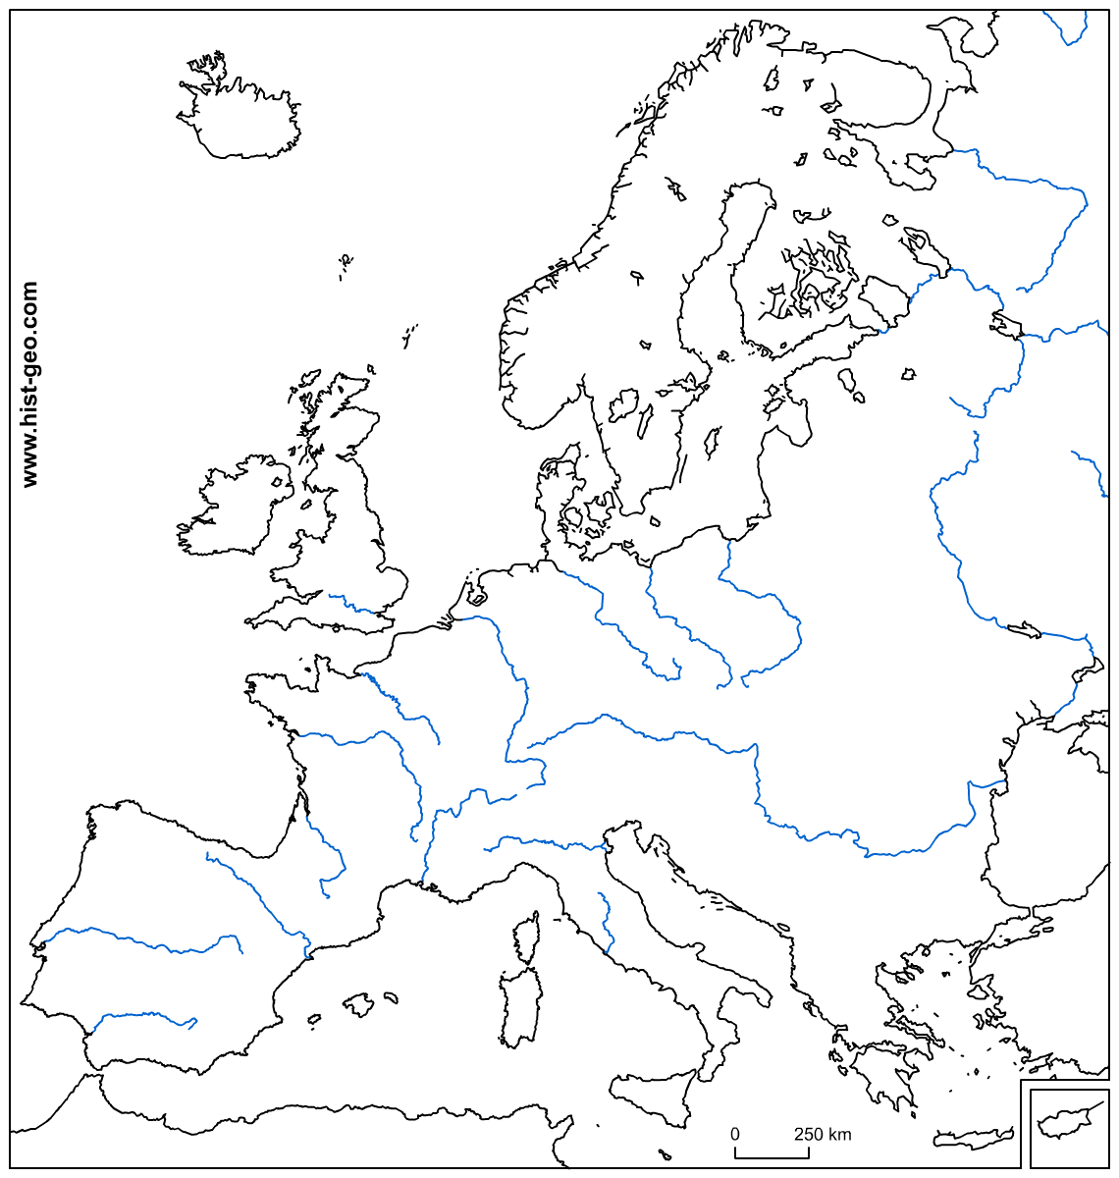
Map Title:___________________________________________________

Directions: Label and color the entire feature listed below. Use the colors provided and create a Key.

1. Baltic Sea (Blue)
2. Northern European Plain (Green Dots)
3. Iberian Peninsula (Orange Dots)
4. Alps Mountains (Purple Triangles)
5. Danube River (Blue)
6. Apennines Peninsula (Red Dots)
7. Scandinavian Peninsula (Brown Dots)
8. Black Sea (Blue)
9. Mediterranean Sea (Blue)
10. Balkan Peninsula (Yellow Dots)
11. Atlantic Ocean (outline in Blue)
12. Arctic Ocean (outline in Blue)

Physical Map
(20 Points Total)

______(10) Coloring
______(10) Labeling
_______Total

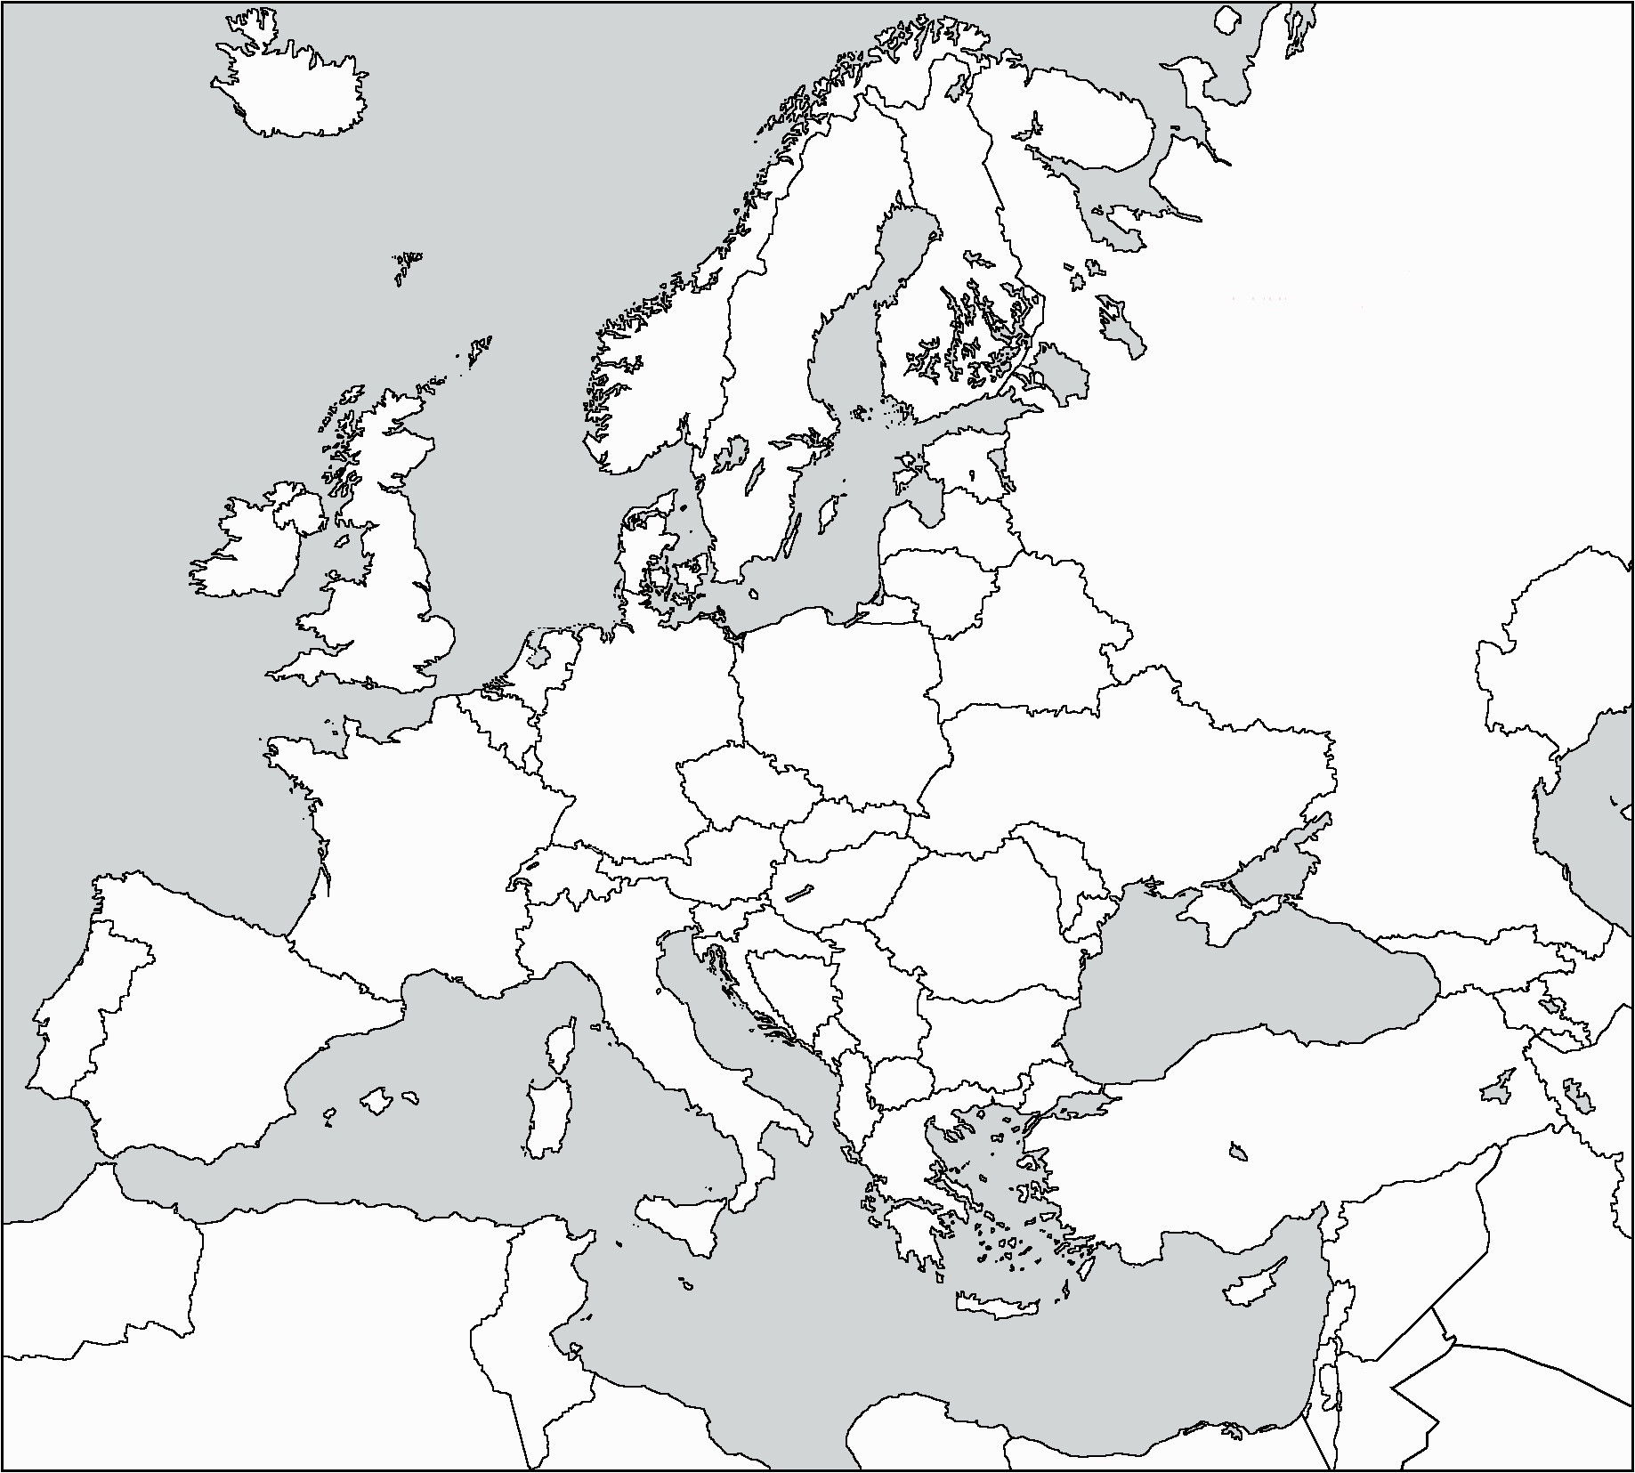
Color in and LABEL the following regions of Europe.

1. Northern Region- Purple Use page 283 in text; 5 countries.

2. Western Europe-Green
Use page 308 in text; 11 countries.

3. Southern Europe- Orange
Use page 328 in Text; 8 countries.

4. Eastern Europe-Yellow
Use page 344 in text; 18 countries

5. Russian Core-Red
Use page 373 in text; 3 Countries

*If a country was left out, critically think what region is should belong to and add it in. Only color

Regional Map (20 Points Total)
____________(10 Labeling)
____________(10 Coloring)

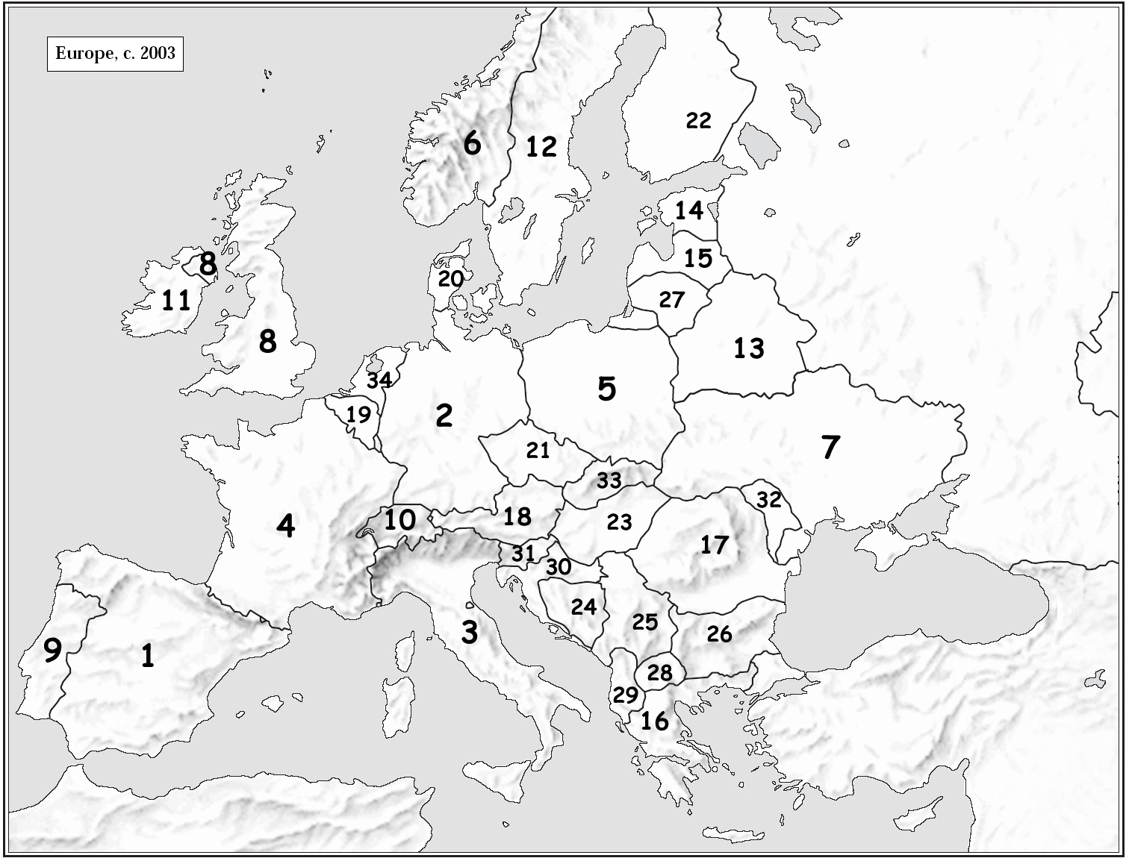
Directions: Using the map below, and your atlas, label the following countries in the blanks provided.
Political Map (20 Points Total)
____________(20)
.1.__________________________
2. __________________________
3. __________________________
4. __________________________
5. __________________________
6. __________________________
7. __________________________
8. __________________________
9. __________________________
10. __________________________
11. __________________________
12. __________________________
13. __________________________
35
14. __________________________ 15. __________________________ 16. __________________________ 17. __________________________
18. __________________________ 19. __________________________ 20. __________________________ 21. __________________________
22. __________________________ 23. __________________________ 24. __________________________ 25. __________________________
26. __________________________ 27. __________________________ 28. __________________________ 29. __________________________
30. __________________________ 31. __________________________ 32. __________________________ 33. __________________________
34. _________________________ 35. __________________________
Questions (40 Points Total)
_______(40)
Directions: Using the provided coordinates, locate the countries of Europe. No country will be used more than once. Use page 70-71 in Atlas.
1. (48’N, 15’E)____________ 2. (50’N,30’E)_____________ 3. (45’N,15’E)____________ 4. (45’N,25’E)_____________
5. (60’N,50’E)____________ 6. (53’N,20’E)_____________ 7. (50’N,10’E)____________ 8. (40’N,22’E)_____________
9. (47’N,20’E)____________ 10. (65’N,25’E)_____________ 11. (45’N,10’E)___________ 12. (56’N,25’E)____________
Directions: Using your atlas, page 70-76 answer the following questions.
1 | In which region of Europe can you find more canal systems?
2 | What highly populated city of Europe lies on the Prime Meridian?
3 | What mountain range runs north and south, along 60’E Longitude and separates European Russia from Asian Russia?
4 | Which Region of Europe has the overall lowest population density?
5 | What commonality do you see in areas that have the highest amounts of precipitation?
6 | What is the most common type of land use in Europe?
7 | What river runs through the center of Hungary, into Serbia, and then runs along the border between Romania and Bulgaria?
8 | What causes Italy to have an average of 8-12 month growing season? Use geographic terminology to support your answer.

