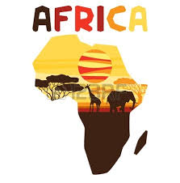
Africa’s Diverse Religious and Ethnic Groups

A Diverse Africa

Africa is a diverse continent made of 54 countries and a variety of ethnic groups and religious groups. An ethnic group is a group of people with a common family tree and ancestry who share cultural ideas and beliefs that have been part of their community for generations. The characteristics could share include language, religion, a shared history, types of foods, and a set of traditional stories, beliefs, or celebrations. Some of the larger ethnic groups in Africa are the Arabs, Ashanti, Bantu, and Swahili peoples.
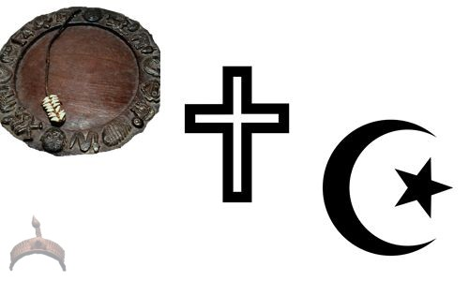
The major religions practiced in Africa are Islam, Christianity, and traditional beliefs. A religious group shares a belief system in a god or gods, with a specific set of rituals and literature. People from difference ethnic groups may share the same religion, though they may be from very different cultures. Most Africans today are Christian or Muslim, but traditional beliefs and customs still play a major rile in African culture. Also, a religious group normally only shares a common spiritual belief system.

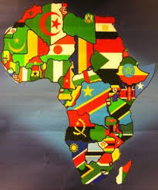
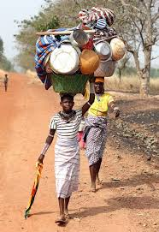
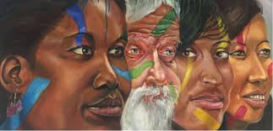

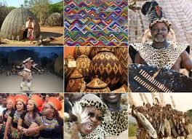

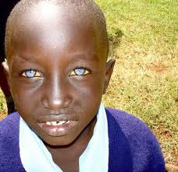
African Arabs
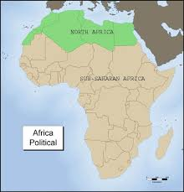
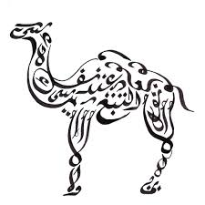
Arab people began to spread into North Africa in the late 600s AD, when the first Muslim armies arrived in Egypt. From here, Arab armies, traders, and scholars spread across the northern Africa all the way to Morocco. Wherever the Arabs went, they took Islam and the Arabic language with them. Arabic traders began to lead caravans south across the Sahara Desert in the gold and salt trade. This brought Islam and Arab culture to the Sahel region and beyond. Along the coast of Africa, Arab traders traveled by land and by sea down to present day Kenya, Mozambique, Tanzania, and Zanzibar. They married local women and the process of blending cultures and religions began. The Arabic language, the religion of Islam, and many other aspects of Muslim culture became part of Africa. Today, Muslims are found throughout Africa. They make up a majority of the people living along the Mediterranean coast and in some countries along the Indian Ocean.

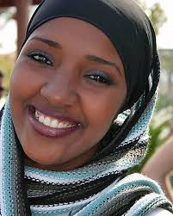

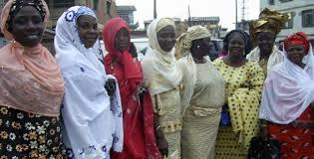

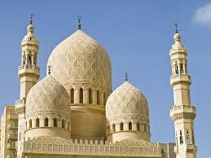
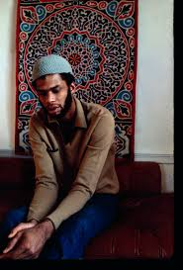

Ashanti
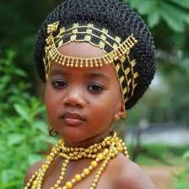

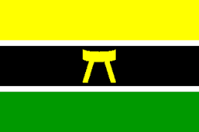
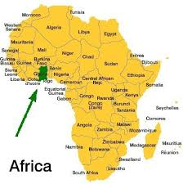
The Ashanti people are found in the modern day country of Ghana. They have been a powerful group in this part of Africa for over three hundred years. Their culture has played a part in the countries around them, including Burkina Faso, Ivory Coast, and Togo. The Ashanti believe that their kingdom was founded in 1701 with the help of a holy man who produced a golden stool from the heavens and gave it to the first Ashanti king. The stool came to symbolize Ashanti power and the belief is that the kingdom will last as long as the golden stool remains in the hands of the Ashanti King. The traditional religion of the Ashanti is centered on a belief in a supreme god, or Nayme. His many children, the Abosom, represent all the natural powers and forces in the world. The traditional Ashanti believe that all living things have souls. They also believe that witches, demon spirits, and fairies have powers in the lives of men. Ancestors are given great respect, and there are a number of family rituals associated with birth, puberty, marriage, and death.

Other religions are also practiced by many of the Ashanti. Christianity has gained many followers in Ghana (and along the West coast of Africa) where it was introduced by European and American missionaries, beginning in the 1800’s. There are also a large number of Muslims. Like so many other places in Africa, movement of people through the centuries has resulted in a great deal of diversity in nearly all aspects of life among the Ashanti.

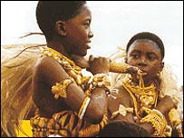
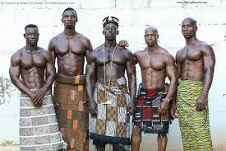

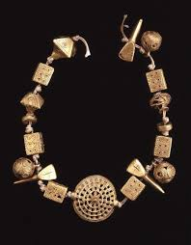
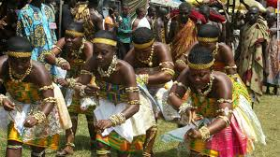

Bantu

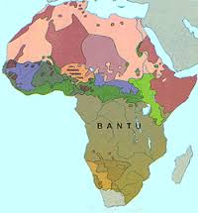
The Bantu speaking people of Africa migrated in many different waves from the region just south of the Sahara Desert to the central and southern parts of the continent beginning over 2,000 years ago. Today the speakers of the hundreds of Bantu related languages include many different ethnic groups, though they share a number of cultural characteristics. From the earliest days, the Bantu were known as farmers and animal herders, and they learned iron-making crafts as well. As they spread south and east across the continent, following rivers and streams, they met many new people and learned new skills, as they shared their own. Bantu speaking people settled as far south as the southern tip of Africa. They intermarried with the people they met, excepting new traditions and blending with Bantu culture. The Bantu migration was one of the largest movements of people in African history. Today, over 60 million people in central and south Africa speak Bantu-based languages and share some part of the Bantu culture.

Many Bantu who settled in the areas where there was a strong Arab presence are Muslim. Others, living in parts of Africa influenced by missionary efforts are Christian. Still others follow traditional animist religions. Animists believe that spirits are found in natural objects and surroundings. They may feel a spiritual presence in rocks, trees, waterfalls, or a particularly beautiful place in the forest.
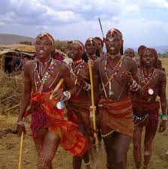

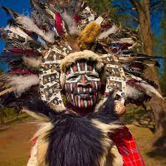

Swahili

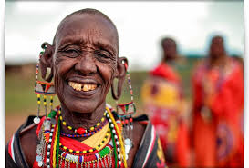
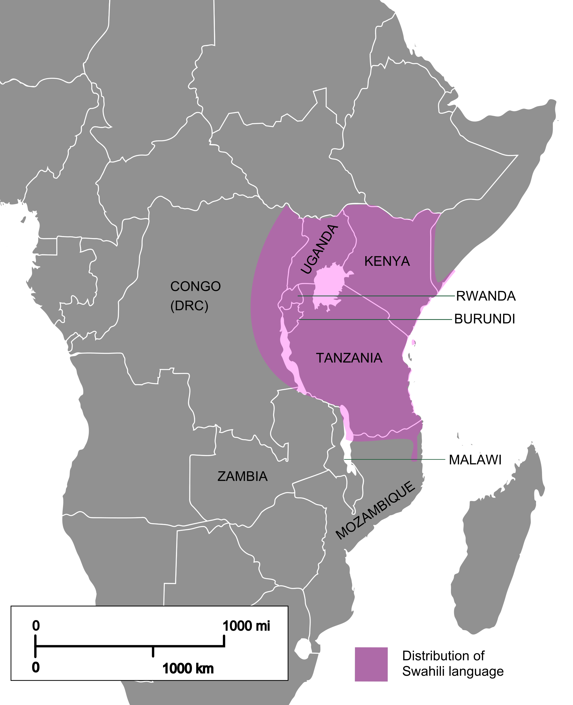
The Swahili community developed along the cost of east African when Arab and Persian traders looking for profitable markets began to settle and inter-marry with local Bantu speaking people. The resulting Swahili culture is a mix of people who can claim ancestors in Africa, in Arabic Lands, and even across the Indian Ocean. Many people in the countries of Kenya, Tanzania, and Mozambique share the Swahilis culture, history and traditions. While the Swahili language is considered a Bantu language, there are many Arabic words or phrases included as well. The word Swahili comes from the Arabic translation, “One Who Lives on the Coast”. Most Swahili today are city dwellers rather than traditional farmers and herdsmen. Many are engaged in fishing and trade, as there ancestors were.

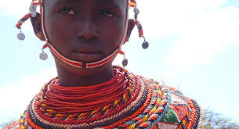
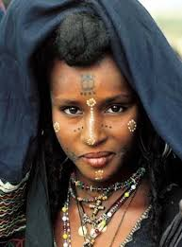
Because of contact with Arab traders was such a big part of their history; most of the Swahili today are Muslim. Islam has been one of the factors that helped created a common identity for such a diverse group of people. It is not unusual for Swahili men to wear charms around their necks containing verses of the Koran to protect them from harm. The Koran is the holy book of the Muslims. Many among the Swahili also follow traditional beliefs that have been part of the culture of eastern Africa since before Muslim traders arrived over a thousand years ago. These local beliefs are known as mila. One belief that is part of mila is that spirits can possess a person. Many Swahili also see a close line between religious beliefs and the practice of medicine and healing. Herbal medicines are often given along with prescribed prayers and rituals that are all thought to be part of the cure.

