Introduction: Economic Sectors

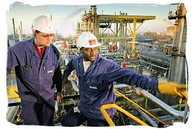
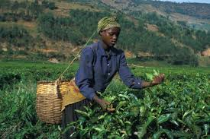

Introduction
1. Africa has the worst economy in the world and is the poorest inhabited continent.
2. Overall, Africa's economy is rising slowly, but only about 1 to 2 percent per year.
~Over 36 percent of Africa’s population lives on under a dollar per day.
3. Starvation and famine also continue to rise in Africa, not because food isn't available but, because of low income and no purchasing power.
4. There are four major economic sectors that can be found throughout Africa.
~Primary
~Secondary
~ Tertiary
~Quaternary

Primary Sector
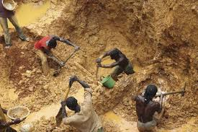
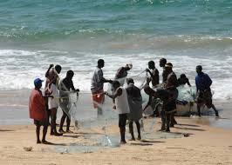

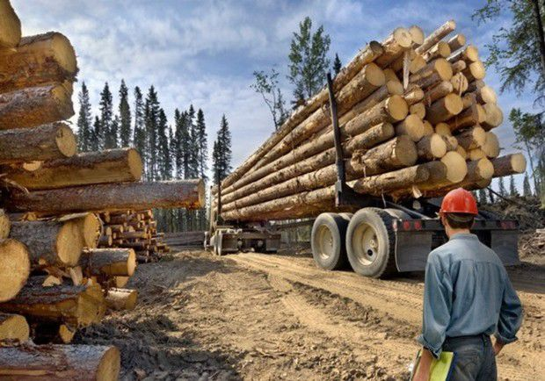
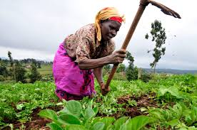

Use of basic materials: Primary Sector

1. The Primary Sector is the portion of the country’s economy that relies on basic natural resources like mining, fishing, agriculture and forestry.

2. Productivity and reliability varies in these industries because they depend on weather and natural elements (fertile soil, rain, no droughts).

3. They are also dependent upon exchange rates and other industries to set their prices, because the manufactures have more economic pull than, you, as a farmer.

4. Mining is a major industry in Africa, due to the global demand for diamonds, coal, and gold. All of these jobs and industries fall in the primary economic sector.

5. Primary Sector Workers often work for extremely low wages, or bring in zero money if they are working on their own land.

6. To move out of the primary sector and into the secondary sector is the hardest of all moves, as you have no way to earn or save money.

Secondary Sector
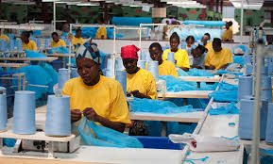
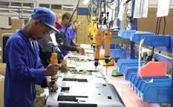

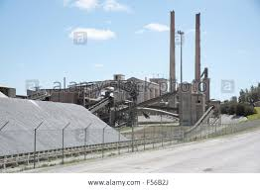
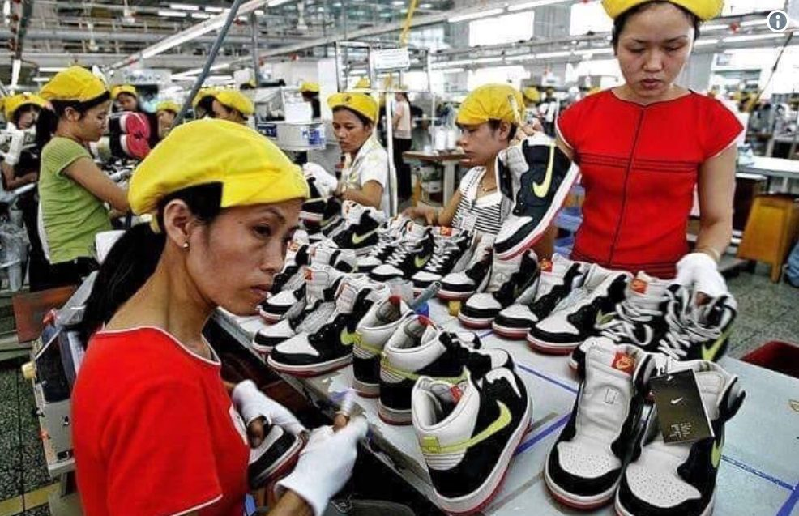

Processing sector: Secondary Sector
1. The Secondary Sector is made up of activities that process basic materials obtained by the primary sector, and turn them into products.
~An example would be coal transformed into energy.
2. The secondary sector in Africa has grown at a steady pace since 1999, but Africa, as a continent, is not keeping up with worldwide improvements.
3. Africa has a large selection of manufacturing consisting of textiles, clothing, footwear, and the manufacturing of basic woods and metals.
4. Electricity, gas, and water industries in the secondary sectors have fluctuated markedly over the past 10 years.
~They appear to be very sensitive to changing economic trends.
5. Secondary Sector workers typically work long hours in dangerous jobs.
6. Most workers learn a trade or skill from a family member. A
~though wages are earned, it is rarely enough to be considered wealthy.
7. Most secondary workers in Africa are above the poverty line, however they could easily fall back into poverty.

Tertiary Sector

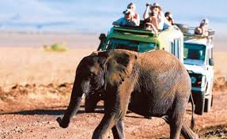

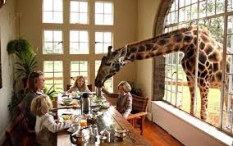

Service sector: Tertiary Sector
1. The tertiary sector consists of a range of service activities and has grown strongly in the country of South Africa since 1994.
~ Services related to transport, storage, communication, real estate,
2. General government services have showed the lowest growth over the past decade.
3. The growth in the hospitality industry, represented by hotels and restaurants, indicates the growing importance of tourism in South Africa.
4. Although it is defined as a tertiary sector activity, tourism in South Africa depends directly on the country’s natural resource and its conservation and biodiversity base, reinforcing the need for management practices that conserve the nation’s environmental resources.
5. Although South Africa is seeing a large increase in Tertiary Sectors, the rest of the African Continent does not have a large tertiary sector.
6. Tertiary Sector Workers go to work and do not usually ‘make’ anything, but it is a job done for someone else.
~Poor countries cant afford to have people go to work and not ‘make anything’

Quaternary Sector

Information and Technology: Quaternary Sector
1. The quaternary economic sector is a way to describe a knowledge based part of the economy.
2. Typically includes information services such as information technology, web development, artificial intelligence, and media specialists.
3. Most of these jobs rely on highly trained and specific education, usually from the university level.
4. Quaternary sectors are some of the highest paid jobs, and have only recently emerged as its own economic sector.
5. Developed nations see more jobs and people within this sector, as it is a direct correlation to development and HDI.
~Many nations in Africa are just emerging into this field, as the nations become more developed.
6. Although the physical work of diamond mines are part of the primary sector, the GIS, GPS, and Sonar to find the diamonds are part of the quaternary sector.

Name__________________________________________Date________Period_________

Economic Sectors of Africa Notes
Introduction: Economic Sectors
1. Africa has_______________________and is the __________ _____________________________.
2. Overall, Africa's _______________________________, but only about 1 to 2 percent per year.
~Over 36 percent of Africa’s population lives on under a_______________.
3. ____________________ and famine also continue to rise in Africa, not because food isn't available but, because of low income and no ______________ ____________.
4. There are ______major economic sectors that can be found throughout Africa.
~______________________~______________________
~______________________~______________________

Use of basic materials: Primary Sector

1. The Primary Sector is the portion of the country’s economy that relies on ___________________like __________, ___________________________and forestry.

2. Productivity and reliability varies in these industries because they depend on _____________________ and ______________________ (fertile soil, rain, no droughts).

3. They are also dependent upon _________________ and other industries to set their prices, because the _____________________have more ____________________ than, you, as a farmer.

4. ______________is a major industry in Africa, due to the global demand for__________________________, and__________________. All of these jobs and industries fall in the primary economic sector.

5. Primary Sector Workers often work for ________________________, or bring in ____________ _______if they are working on their own land.

6. To move out of the primary sector and into the secondary sector is the ___________________________ as you have no way to earn or save money.

Processing sector
1. The ______________________is made up of activities that ______________basic materials obtained by the primary sector, and turn them into ________________.
~Example: coal transformed into energy.
2. The secondary sector in Africa has ____________at a steady pace since 1999, but Africa, as a continent, is _________ keeping up with ____________improvements.
3. Africa has a large selection of manufacturing consisting of________, __________, ____________, and the manufacturing of basic __________and___________.
4. Electricity, gas, and water industries in the secondary sectors have ____________________markedly over the past _________________
~They appear to be very sensitive to changing __________________trends.
5. Secondary Sector workers typically work ______________ in ___________________jobs.
6. Most workers learn a___________________________.
~ it is rarely enough to be considered___________.
7. Most secondary workers in Africa are above the _______________line, however they could easily fall back into poverty.

Service: Tertiary Sector
1. The __________________consists of a range of _____________________________ and has grown strongly in the country of South Africa since 1994.
~ Services related to transport, storage, communication, real estate,
2. General ______________________have showed the __________________over the past decade.
3. The growth in the________________________, represented by hotels and restaurants, indicates the growing importance of ________________in South Africa.
4. Although it is defined as a tertiary sector activity, tourism in South Africa depends ____________on the country’s ___________________and its ___________________ and __________________base, reinforcing the need for _______________________that conserve the ______________environmental___________________.
5. Although South Africa is seeing a large increase in Tertiary Sectors, the rest of the _____________________ does __________have a large______________________.
6. Tertiary Sector Workers go to work and do not usually ‘____________’ anything, but it is a job done for someone else.

~___________________ countries cant afford to have people go to work and not ‘make anything’

Information and Technology: Quaternary Sector
1. The ______________________ economic sector is a way to describe a _________________________ based part of the economy.
2. Typically includes information services such as______________________________, web development, _____________________________________and media specialists.
3. Most of these jobs rely on highly ____________________and___________________ _______________, usually from the university level.
4. Quaternary sectors are some of the______________________________, and have only _____________________emerged as its own economic sector.
5. Developed nations see more jobs and people within this sector, as it is a direct _____________________________________________and HDI.
~Many nations in ________________are just emerging into this field, as the nation’s become more developed.
6. Although the physical work of diamond mines are part of the primary sector, the___________, _______________, and ________________to find the diamonds are part of the quaternary sector.

