Early Civilization Notes
The Mayans  1. Central America and Southern Mexico  2. Pyramids, Temples, Mid sized urban areas.  3. farming and Ag (corn)  4. Calendar, Concept of Zero, First written language (hieroglyphics)  5. Nature Gods (Corn, Sun)  6. disappeared- Drought, Invasion, Volcano  7. Still 7 Million Mayans today throughout Mexico and Central America | The Aztecs  1. Central and Northern Mexico  2. Temples, palaces, and Canals, Pyramids.  Large cities  3. Farmed on manmade islands  4. Canals, Irrigation, Calendars, Mexican Flag (Eagle). Chocolate and Tortillas  5. All the nature Gods (Rain, Sun, Fertility)  Quetzalcoatl (feathered Serpent). Human Sacrifice  6. Contracted diseases from Spanish and then taken over  7. Only limited cultural connections remain | The Incans  1 Along the Andes Mountains in South America  2. Large Temples and cities atop the mountains  3.Terrace farming on the sides of a mountain  4. Decimals.  5. Sun God  6. taken by the Spanish explorers  7.Large Incan population in Peru  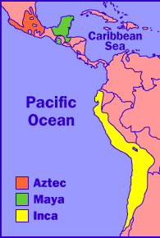
1. Where were they located
2. What their cities were like
3. What types of Jobs
4. Inventions and Advancements they left for us today
5. Beliefs/Spirits
6. What happened to them
7. Do they remain today?

