Name____________________________________________________________________Date______________________________Period___________________
Crisis in South Sudan

Directions: Review the diagrams below and answer all questions. Be sure to think critically and use your social skills and knowledge.

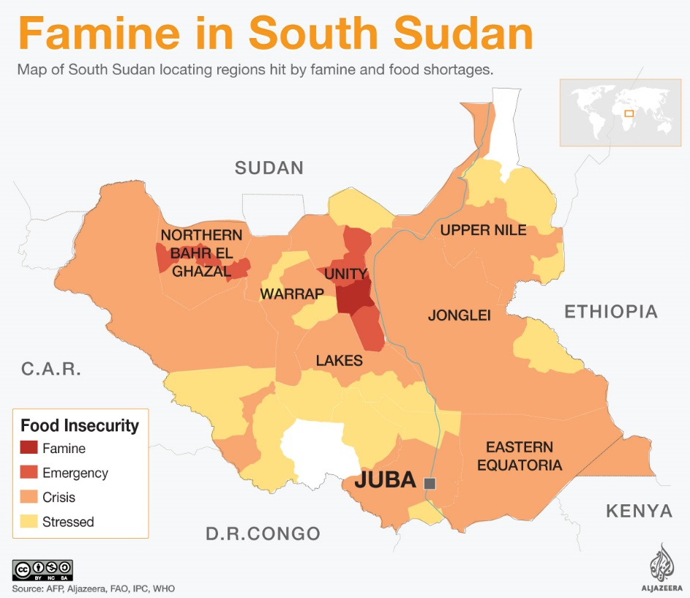
Diagram 2
Diagram 1
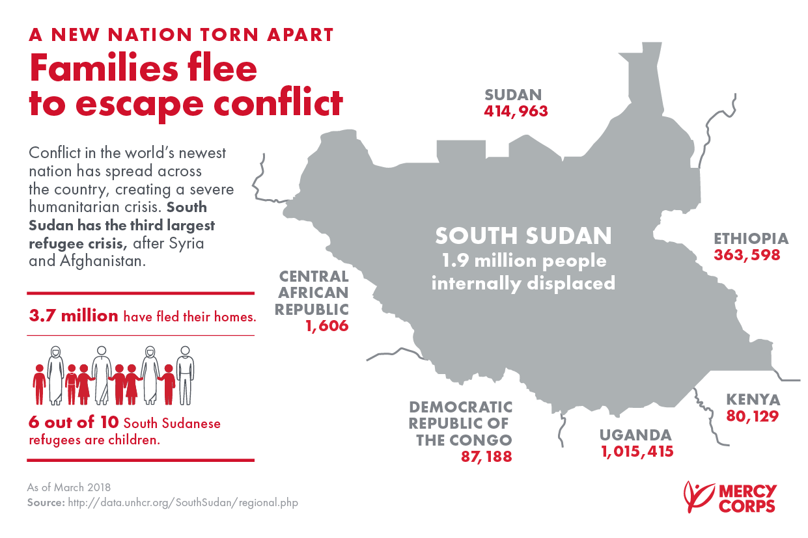

- According to the key in diagram 2, what are the 4 levels of food insecurity? __________________________________________________________________
- How many South Sudanese refugees are children?_______________________________________________________________________________________________
- Using the information in diagram 1, what has caused this severe humanitarian crisis?_______________________________________________________
- What is the most common level of food insecurity in diagram 2? _______________________________________________________________________________
- How many South Sudanese are currently displaced internally? _________________________________________________________________________________
- According to diagram 2, how many South Sudanese had fled their homes? ____________________________________________________________________

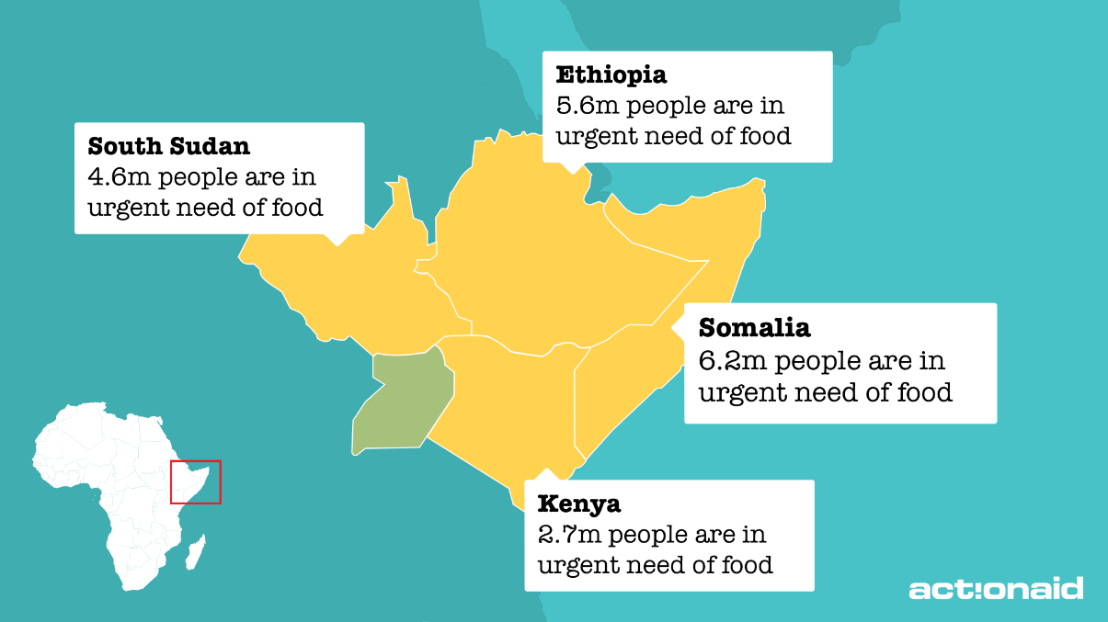
Diagram 3

- What does diagram 3 say about these countries’ level of development? _______________________________________________________________________

- Using the map on diagram 3, what region is most greatly affected by food shortages? _______________________________________________________________________

- According to the image, which country has the most people in urgent need of food? _______________________________________________________________________

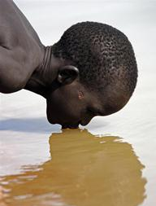
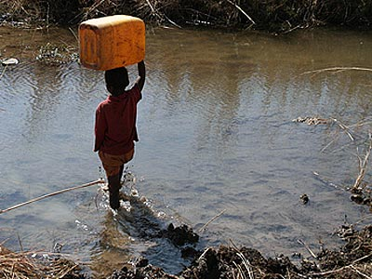
Image 1
- Images 1 and 2 provide examples of how ________________________________________ can spread.

- Using the evidence in Images 1 and 2, what is the level of development for South Sudan? _______________________________________________________________

- Using the diagrams and images, what resources are needed most in this region? _______________________________________________________________
Image 2

Short Answer: Based on the information above, what conclusion can be made about the correlation between famine and the refugee crisis in South Sudan? _________________________________________________________________________________________________________________________________________________
_________________________________________________________________________________________________________________________________________________________________
_________________________________________________________________________________________________________________________________________________________________
_________________________________________________________________________________________________________________________________________________________________
_________________________________________________________________________________________________________________________________________________________________
_________________________________________________________________________________________________________________________________________________________________

