**Canada’s Major Regions**

Region:

Population:

Language:

Climate:

Economic Activity:

Region:

Population:

Language:

Climate:

Economic Activity:

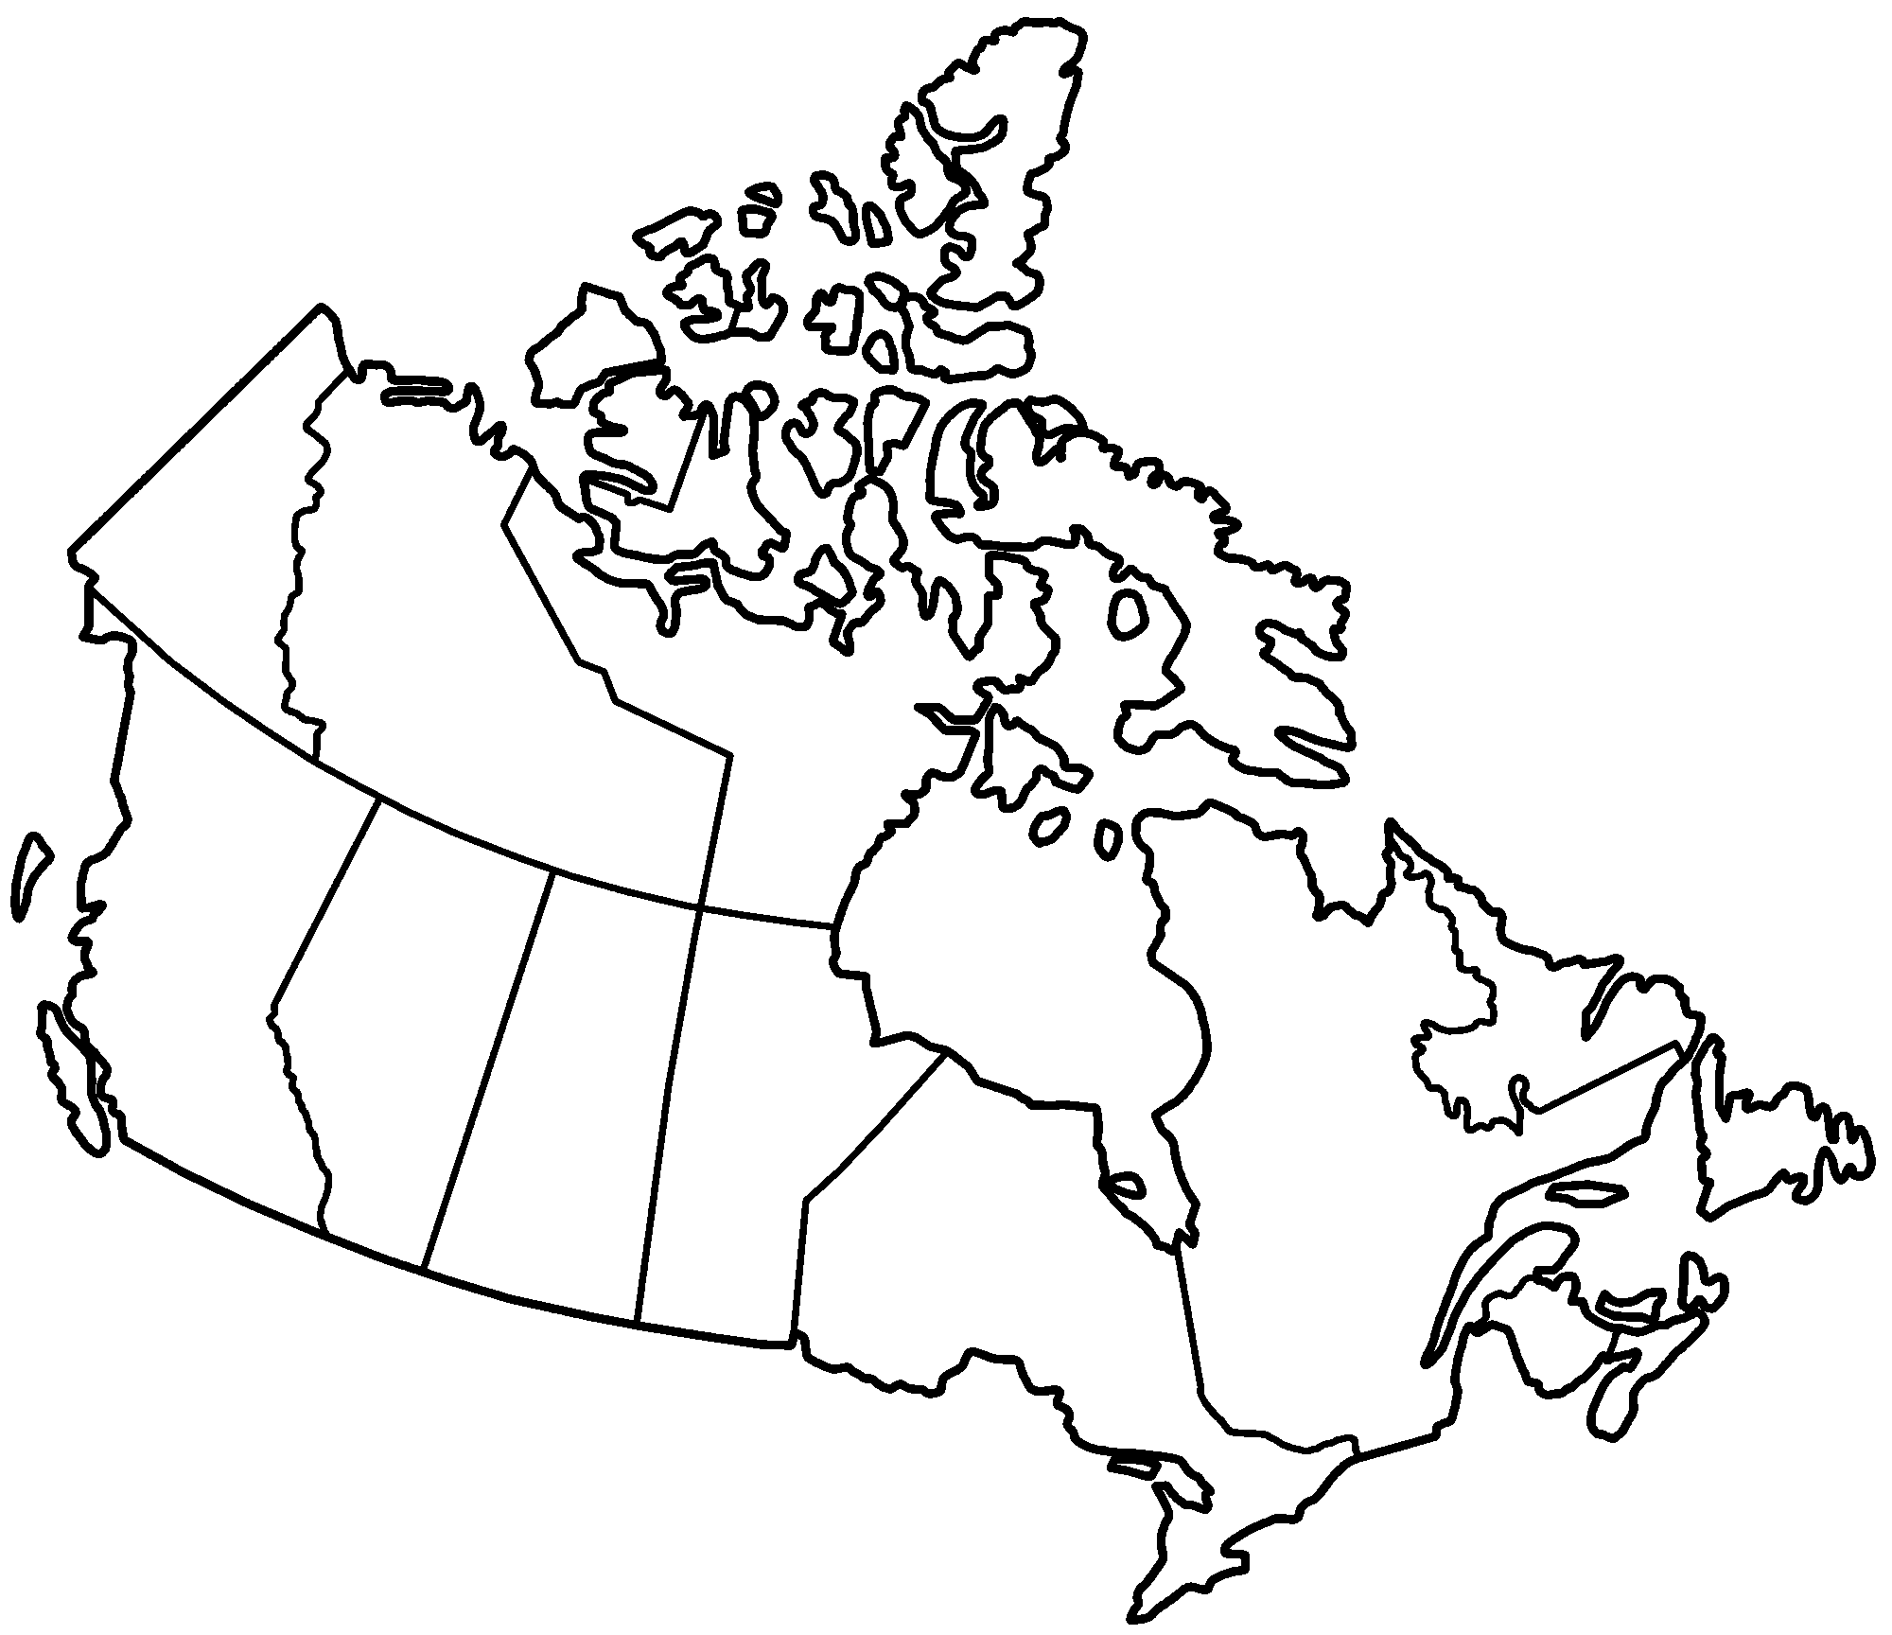

Region:

Population:

Language:

Climate:

Economic Activity:

Region:

Population:

Language:

Climate:

Economic Activity:

Region:

Population:

Language:

Climate:

Economic Activity:

Label the Following locations on your map:

1. Vancouver, Calgary, Toronto, Ottawa, Montreal, Edmonton.

2. What can you tell from the image about Canadian Population Density?