Name_________________________Date___________________Period____________
Conflict Diamonds: Atrocities and Genocide

1. Africa is a continent that is rich in natural resources and mineral wealth. Because of this, many countries throughout the world have scrambled to claim a piece of Africa, stripping the continent and its people of their great wealth. The diamond is one such mineral that has led to wide spread grief and death. Diamonds are a rare and expensive mineral and the continent of Africa makes up 65% of the world’s diamond supply. Part of the problem of diamonds is that this mineral is desired by many peoples throughout the world. This is true for peoples in Europe and the United States especially because a diamond represents, love, commitment, and luxury. Thanks to the DeBeers Jewelry campaign, diamonds are now the common element of proposals and weddings.
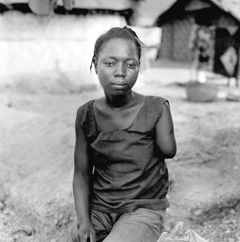
2. Due to the high demand for these precious stones it has led to various conflicts and violations of human rights. First off, many of the people who mine diamonds are either paid a very low wage, or forced to work at gun point for free- modern day slave labor. Often times, rebel groups enslave, kill, rape, and amputate the limbs of people who they thing may have stolen from the diamond mines. If a rebel soldier suspects a miner of keeping a diamond for himself, this would also be grounds to amputate or shoot a person. Areas with diamond mines in Africa have the highest rate of amputees in any part of the world. The desire for diamonds has also led to the kidnapping of children, who are then used as child soldiers or mine workers. These children have been known to kill enslaved miners who have not been successful in extracting diamonds from the earth.
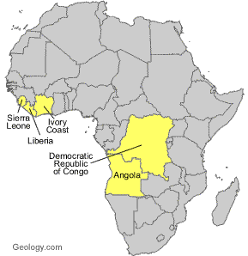
3. The most devastating effect of diamonds is that it has helped to fuel civil wars in as many as 7 African countries. Some of these countries include: Sierra Leone, Liberia, Angola, the Democratic Republic of Congo, and Cote d’ Ivoire. In many of these countries, genocide (the deliberate killing of large groups of people from a particular ethnic group) has destroyed entire towns and villages. The country of Sierra Leone is a primary example of these types of atrocities. In total, 3.7 million lives have been lost to conflict diamonds.
4. Lastly, the conditions in legal governmentally owned diamond mines are no better. The average salary of a diamond miner can be as little as 50 cents a day. This salary is only guaranteed if the miner manages to be successful in panning for diamonds. All too often, the government of a country in Africa is corrupt, hoarding much of the wealth that is earned from diamonds. Conflict diamonds is such a huge problem in Africa, that it even helped inspire a 2006 film entitled, “Blood Diamond”.

The Kimberley Process
5. The Kimberley Process is a commitment by the United Nations to prevent “conflict diamonds” from entering the global supply chain. It started when Southern African diamond-producing states met in Kimberley, South Africa, in May 2000, to discuss ways to stop the trade of ‘conflict diamonds' and ensure that diamond purchases were not financing violence by rebel movements or their allies who were seeking to undermine legitimate governments.
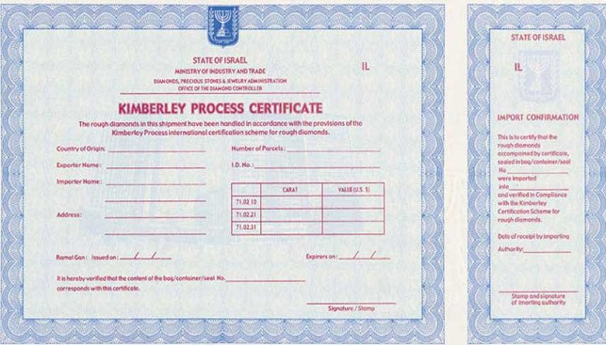
6. In 2003, the United Nations General Assembly adopted a resolution supporting the creation of an international certification scheme for rough diamonds. This became known as the Kimberley Process Certification Scheme (KPCS). The Kimberley Process is open to all countries that are willing and able to abide by its requirements. In order for a diamond to be deemed “conflict-free”, a certificate of authenticity must be presented, stating the origin of the diamonds and how they were legally and humanely mined.
7. The goal of the United Nations in establishing the Kimberley Process was to reduce or remove conflict diamonds from entering the legal trade of diamonds. It is through this process that governments and consumers in Europe and the United States, hope to prevent the funding of weapons that are used by terrorist or rebel groups that use this means of illegal trade to fund civil wars and government takeovers throughout many parts of Africa, and the world.
8. Critics of the Kimberley Process argue that although this act is a step in the right direction, it is still difficult to tell whether this system actually works in verifying that only “conflict-free” diamonds reach the hands of consumers. Although the trade of diamonds is in the hands of legitimate governments, the possibility exists for corrupt governments to allow smuggled diamonds to enter into the legal supply chain. Many diamonds are easily smuggled because of their relatively small size. Furthermore, the African continent consist of 54 countries, and ensuring that all 54 nations are following protocols all of the time is virtually impossible. Still, the Kimberley Process is a step in the right direction, and is bringing the topic of Blood Diamonds to the world’s attention. Today, in the United States and Europe, you can ask for a Kimberley Certification before purchasing diamonds to ensure that you are not supporting blood diamonds from Africa.

The Human and Geographic impact of Conflict Diamonds
9. Diamonds are one of Africa’s most abundant natural resources. Diamonds are more than just a luxury item, they can also be used for industrial purposes such as grinding, polishing, cutting, and drilling. Annually, diamonds produce $8.5 billion in sales for Africa alone. This kind of revenue is staggering to comprehend, yet diamonds have devastated the continent in many ways.
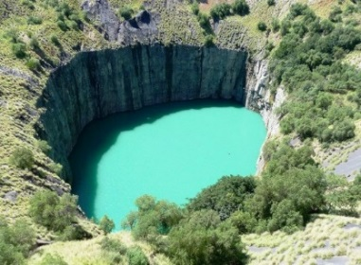
10. The human impact of diamonds comes in the form of smuggling and the funding of civil wars, leading to government take overs in Africa by rebel groups. Many of these groups sell rough, uncut diamonds, or blood diamonds, and use the profits to purchase weapons from Eastern European countries such as Ukraine and Bulgaria. Many of these weapons have also ended up in the hands of terrorists, leading to horrific events, such as the terror attack on the United States, on September 11, 2001.
11. As for the geographic impact, diamonds have also managed to devastate the natural environment. The mining of diamonds is back-breaking work. In order to extract diamonds from the earth, miners must dig holes that can be between 50 and 700 feet deep. One of the biggest diamonds mines is located in South Africa, known as the Kimberley mine, or “The Big Hole.” Once these diamond mines have served their purpose, these holes fill up with water becoming stagnant, and allows for the breeding of mosquitos and outbreaks of malaria. These diamond mines can also lead to soil erosion and deforestation of the surrounding environment. Also, wherever a diamond mine is found, human traffic changes and scars the natural landscapes due to trucks, machinery, and industrialization.
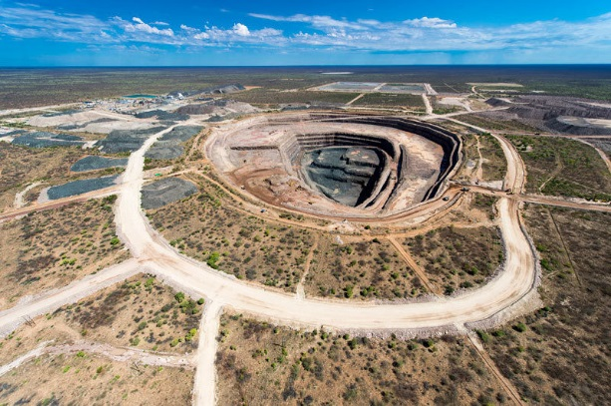
12. Diamond mines also affect ecosystems. In some cases, diamond miners must re-route rivers and construction dams to mine for diamonds. This can mean life or death for fish and other wildlife that depend on the flow of a river. Water is already scarce in many African locations, so changing or cutting off a water supply is often a death sentence for plants, animals, and people. The Congo River Basin is also seeing the effects of large scale diamond mines. Deforestation and habitat loss are increasing along the natural waterways.
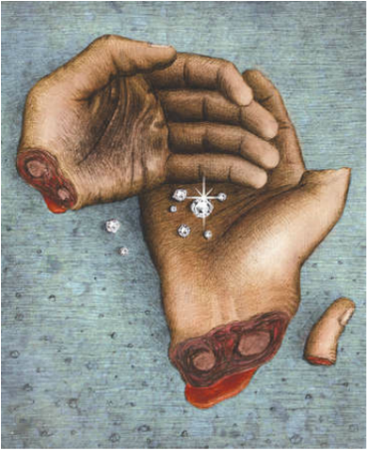
13. For some people, diamonds are a spectacular show of love and symbolize beauty, and wealth. For others diamonds are the cause of war, despair, and death. They are stones that have caused civil wars, mass casualties and are the fueling of wars and terrorism around the world. Blood diamonds are circulating, but with more awareness and world support, we can hope that our hands will not be covered in blood diamonds.

Name__________________________
_____________________________________
^{Title Overall}
Period_________ Date____________
______________________________
______________________________
____________________________

