Name: _______________________________________________Date: ___________________________Period: _________ISN# 6.1
Physical Geo of Eastern Europe
Arctic Claims
- Russia - Norway - Denmark - Canada - United States - Iceland

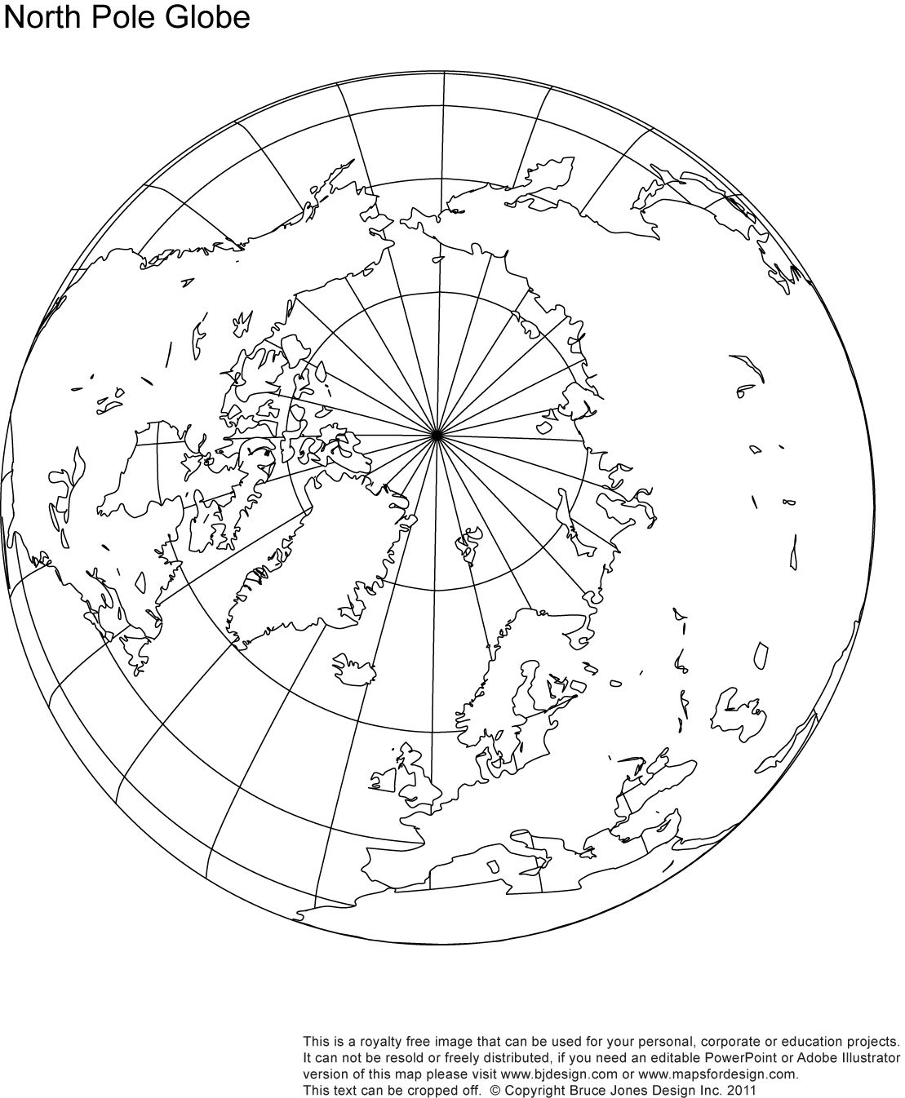

If the Arctic were divided evenly, __________________ would benefit the most.
If the Arctic were divided using location, ________________ would benefit the most.

Map comparisons
Use the maps provided to determine which quadrant of Eastern Europe/Russia is the best. For each map, choose which quadrant you think is the best for that topic.
Map 1: Physical Features
Quadrant #_______ is the best because ______________________________________________________
That is good because _____________________________________________________________________
Map 2: Climate
Quadrant #_______ is the best because ______________________________________________________
That is good because _____________________________________________________________________
Map 3: Biome
Quadrant #_______ is the best because ______________________________________________________
That is good because _____________________________________________________________________
Map 4: Resources
Quadrant #_______ is the best because ______________________________________________________
That is good because _____________________________________________________________________
Map 5: Oil
Quadrant #_______ is the best because ______________________________________________________
That is good because _____________________________________________________________________
Map 6: Electric power
Quadrant #_______ is the best because ______________________________________________________
That is good because _____________________________________________________________________
Based on your findings, which quadrant do you think is the most important in Eastern Europe/Russia? Why?
________________________________________________________________________________________________________________________________________________________________________________________________________________________________________________________________________________________________________________________________________________________________________________________________________________________________________________________________________________________________________________________________________________________________________________________________________________________________________________________________________________________________________________________________________________

