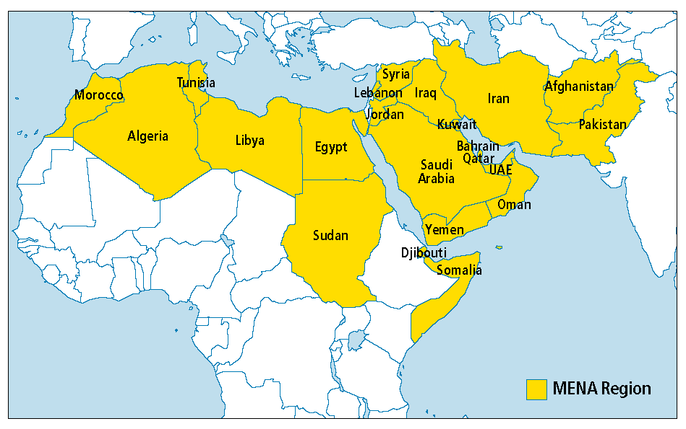

**January 14, 2011- March 11, 2011-** Inspired by events in Egypt and Tunisia, the people of Yemen **protested** their corrupt government. As police fire on protesters, civil war erupts in Yemen. The Yemen president steps down in late 2011.

**Yemen**

**February 14, 2011-March 18, 2011-** During the Bahrain **“Day of Rage”** protests on February 14th, a young protester is killed by police, escalating the situation. The government has been able to suppress most protest efforts.

**Bahrain**

**Syria**

**January 25, 2011-February 11, 2011- Protests** in the cities of Cairo, Alexandria, and across the nation erupt against Egyptian President Hosni Mubarak*. Muburak steps down from power* shortly after the protests begin allowing Egypt to hold its first ever democratic elections in late 2011.

**Egypt**

**Libya**

**Tunisia**

**December 17, 2010-January 4, 2011-**Mohammed Bouazizi sets himself on fire as a protest of the government. Shortly afterward, ***protests*** *against the authoritarian government* begin. The President Ben Ali flees the country in mid-January.

Arab Spring

*The Arab Spring was a series of protests and revolutions that began to spread across the Arab world in late 2010. All protesters shared the same general goals: less corruption in their country’s leadership and more openly democratic forms of government. The outcomes of the Arab Spring have differed between countries. The lasting outcomes of the Arab Spring, positive or negative, are yet to be fully realized.*

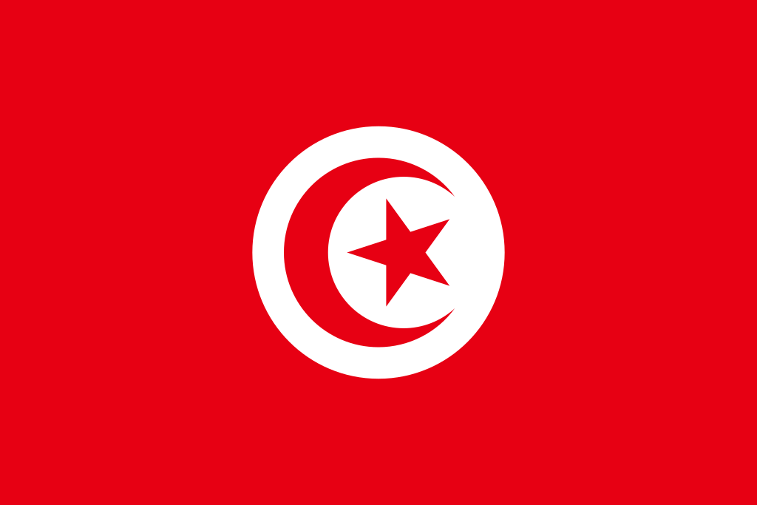

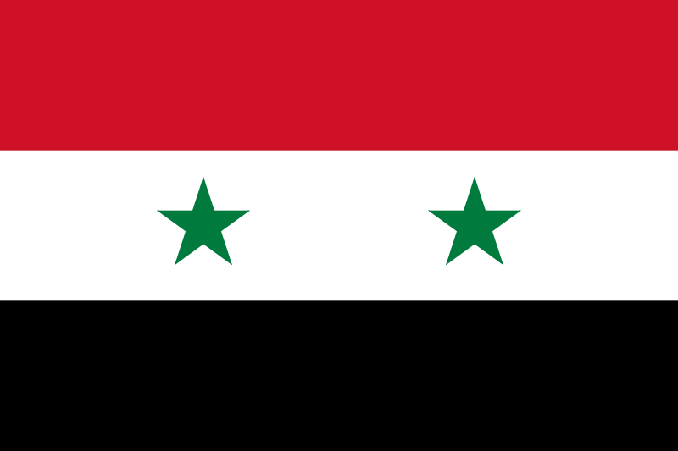

**February 14, 2011-March 18, 2011-** Angry with corruption in their government, Syrian protestors organize a **“Day of Rage”** for mid-February on *Facebook and Twitter*. Sporadic protests in the capital of Damascus and across the country pop up in the following days. Government suppression turns into a civil war.

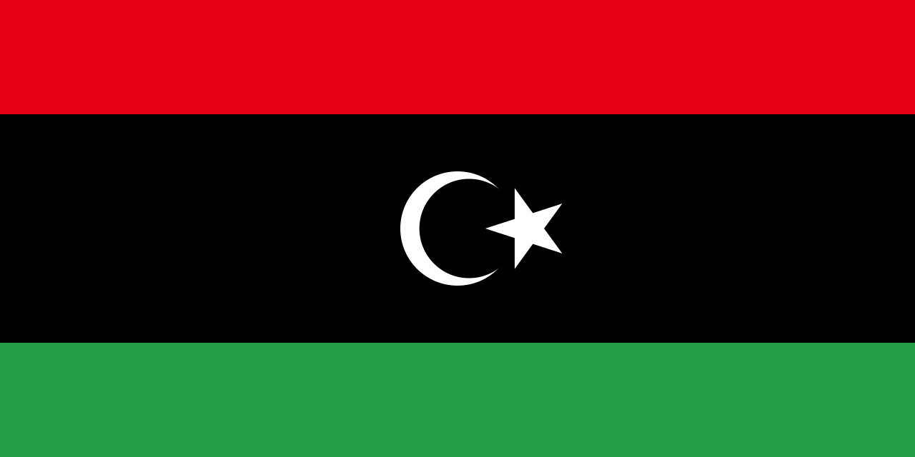

**February 4, 2011-February 15, 2011-** *Calls for* ***protest*** *on the Internet* result in demonstrations in the cities of Benghazi, Tripoli, and across the country. Clashes between protestors and the government turn into a civil war which ends on October 23, 2011, with a rebel victory.

