Name__________________________________________________________________Date_________________Period______________ISN#____________
Amazon Land Conflict
Directions: Use the readings on my Website, under table of Contents page at Www.WorldGeoJLo.Weebly.com to gain information about the current land conflict issues of the Amazon. Then, rank the groups from 1-6 on who should have the land. Be prepared to make a claim and support your choice with evidence.
Group | Description of what it is in | 2 or more Pros | 2 or More Cons | Rank
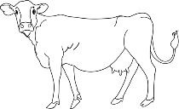
Cattle Ranchers
Environmentalists
Native Amazonians
Rubber Tappers
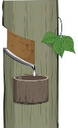
Loggers
Settlers
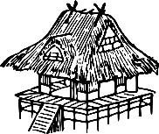
Rank the groups from 1-6. 1 being the group you want MOST to have the Amazon and 6 being the LEAST favored group to have the Amazon.
1. Which groups want to use the Amazon for Renewable resources?  2. Which groups use of the Amazon makes the most money for Brazil and other parts of South America?  3. Why did you rank 4, 5, 6, as the last three groups who should not have claims to the Amazon?  4. Why did you rank 1, 2, 3 the way you did?  5. Why do you think Native Groups have been taken advantage of and have had the least amount of representation compared to large logging companies or cattle ranchers?  6. Do you think it would be possible to divide the Amazon into ‘sections’ so each group could use the Amazon as they wanted? Why or why not?  7. In a perfect world, how would you divide the Amazon?  8. In the ‘real’ world, what do you think the Amazon will look like in 2050? | Free Response  Which group of people do you believe should have the right to claim the Amazon Rainforest and why? Provide evidence for your claim.  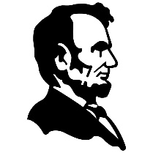  A-Answer The Question  (state who should get the Amazon)  B-Back up your Position  (Use Evidence to support your Answer)  E-Explain your Reasoning  (Tell my why the others shouldn’t get the rainforest)  ______________________________________________________________  ______________________________________________________________  ______________________________________________________________  ______________________________________________________________  ______________________________________________________________  ______________________________________________________________  ______________________________________________________________  ______________________________________________________________  ______________________________________________________________  ______________________________________________________________  ______________________________________________________________  ______________________________________________________________  ______________________________________________________________  ______________________________________________________________  ______________________________________________________________

