The Scramble for Africa
Red | Great Britain
Green | France
Orange | Germany
Purple | Italy
Yellow | Portugal
Brown | Spain
Grey | Ethiopia
Directions: Using the cards provided, create a timeline and a map that explains the Scramble for Africa, European colonization in Africa. The map on page 608 of the World Geography textbook will also be used to help create the map.
- Label and color the map according to the information on the cards and page 608.
- Use red lines to represent areas where the African Natives prospered before European Colonization.

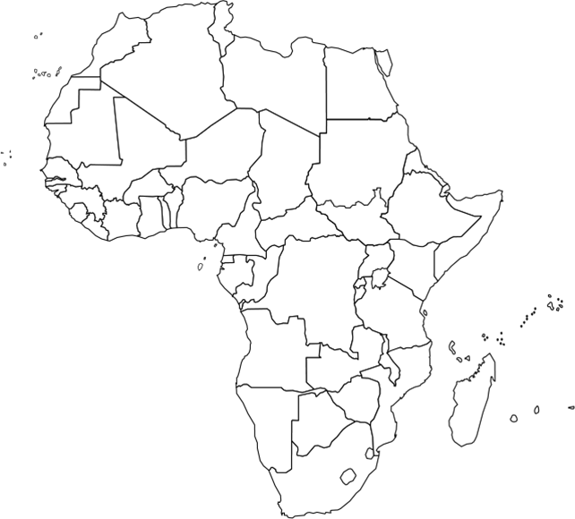

- Create a timeline depicting the events of the Scramble for Africa. Use the colors from the map for each of the European countries.

- Which European country controlled most of inland South Africa? ______________________________________________________________________________
______________________________________________________________________________

- Why do you think West Africans were the first to establish empires?
____________________________________________________________________________________________________________________________________________________________
- Why were the Portuguese more afraid of Europeans than Africans?
____________________________________________________________________________________________________________________________________________________________
- During the Berlin Conference of 1884, Spain was granted control of the least amount of land in Africa, why do you think they were not given more land?
____________________________________________________________________________________________________________________________________________________________
- If Germany had the third-largest colonial power before the Berlin Conference, why did they only get control of small coastline countries after the conference?
____________________________________________________________________________________________________________________________________________________________
- Knowing British colonial history, do you think they were successful governs of their African colonies?
____________________________________________________________________________________________________________________________________________________________
- What resources could France have found in the Senegal River area that maintain French interests there?
____________________________________________________________________________________________________________________________________________________________
- Why would Italy concentrate their efforts on the Mediterranean Coastline?
____________________________________________________________________________________________________________________________________________________________
- What political characteristics would have been established in Ethiopia for them to maintain their independence, even after the Berlin Conference of 1884?
____________________________________________________________________________________________________________________________________________________________

